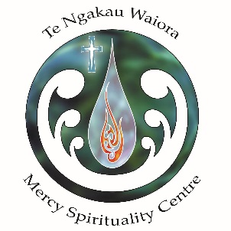
Sabbatical Programme for Senior Sisters

The Sabbatical Programme for senior sisters held at Te Ngakau Waiora Mercy Spirituality Centre in Auckland, New Zealand has become an annual event.
Since 2013, the Centre - an entity of the Sisters of Mercy Aotearoa New Zealand offers six weeks to live, listen, pray and celebrate life.

The Mercy Spirituality Centre is a centre for retreats, spiritual companioning and personal development. The beautiful surroundings and the wonderful garden with many flowers is considered an oasis of peace in the centre of Auckland.
There are only 10 bedrooms available which contributes to the homely atmosphere at the Centre.

The six week programme offered to senior sisters include spiritual workshops, reflections and a five days guided silent retreat. Part of the programme is also connecting with the history of the young country. The highlight is a pilgrimage by bus to the cradle of Catholicism in Aotearoa New Zealand (the Sisters of Mercy were the first religious sisters in the country!).

The Mercy Spirituality Centre core values are Manaakitanga – Hospitality, Te Tapu o te tangata – Respect for Human Dignity and Whakawhanaungatanga – Establishing right relationships with God and Self, Others, Earth.
The Centre is committed to these values and has a wide range of programmes – including this programme especially set up for senior sisters who would like to enjoy six weeks of company, programmes, quiet times and own endeavours.

Here are some comments from previous years:
- Praise and thanks to the Lord for this great gift of the Spirituality Centre. Very important work of Mercy, never end no limit […]
- Beautiful environment, place very functional and good, caring staff. Comfortable and got everything we need […] very good variety, tasty food.
- A wonderful experience, spiritual renewal with a difference. Atmosphere of prayer, peace and joy.

The Sabbatical Programme 2020 is planned for 22 January to 6 March.
See poster attached.

